TITLE:
Design and Apply Context-Aware Access Controls Based on User Identity, Device
Posture, Location, and Application Risk
OVERVIEW:
Context-aware access control is an advanced security approach used to protect systems, applications, and sensitive data from unauthorized access. Traditional access control systems mainly depend on usernames and passwords to verify users. However, these methods are often not sufficient to handle modern cyber threats. Context-aware access control improves security by evaluating multiple factors such as user identity, device posture, location, and application risk before granting access to a system.
One of the most important factors in this approach is user identity verification. Identity verification ensures that the person requesting access is legitimate. This process can include authentication methods such as passwords, multi-factor authentication (MFA), biometrics, or security tokens. Organizations often use Identity and Access Management (IAM) systems to manage user roles and permissions. These systems help ensure that users can access only the resources necessary for their job responsibilities.
Another key component is device posture, which refers to the security status of the device used to access the system. Security systems check whether the device meets certain security requirements before granting access. These checks may include verifying the operating system version, security patch updates, antivirus protection, firewall configuration, and device encryption. If the device does not meet these security standards, access may be restricted or denied. Location awareness is also an important factor in context-aware access control. The system can evaluate the geographic location or network from which the access request is made. Access from trusted locations such as corporate networks may be allowed, while login attempts from unknown or suspicious locations may trigger additional authentication steps or be block.
Another important element is application risk assessment. Different applications have different levels of sensitivity depending on the type of data they handle. For example, financial systems, administrative portals, or healthcare applications require stronger security controls than general information systems.
In addition, content-aware access control focuses on protecting sensitive data being accessed or transferred. Security systems analyze the content of files and data transfers to detect confidential information. Technologies such as data loss prevention (DLP) help prevent unauthorized sharing or leakage of sensitive data.Overall, context-aware access control provides a more secure and flexible method for managing access to digital resources. By evaluating user identity, device security, location, and application risk, organizations can make better access decisions and reduce the risk of cyber attacks.

GROUP DETAILS:

s.no | Name | College Name | Contact
1 | Poojasree A | Shri Nehru  Maha Vidyalaya college of  Arts and  Science | Poojasree710@gmail.com
2 | Bhavesh Gounder. A | Shri Nehru  Maha Vidyalaya college of  Arts and  Science | Neymarbhavesh10@gmail.com
3 | Immanuvel jebasingh .j | Shri Nehru  Maha Vidyalaya college of  Arts and  Science | jabasinghimmanuvel@gmail.com
4 | Sachin.k | Shri Nehru  Maha Vidyalaya college of  Arts and  Science | sachinkesavan001@gmail.com

PROJECT DETAILS:

TITLE:
Design and Apply Context-Aware Access Controls Based on User Identity, Device Posture, Location, and Application Risk

INTRODUCTION:
In modern digital environments, protecting systems and sensitive data from unauthorized access is a major challenge. Traditional access control mechanisms mainly rely on usernames and passwords, which are often not strong enough to defend against modern cyber threats. To improve security, organizations are adopting advanced access control models that evaluate multiple factors before granting access to systems and applications.
Context-aware access control is a security approach that analyzes different contextual attributes such as user identity, device security status, geographic location, and the risk level of the application being accessed. By evaluating these factors, the system can determine whether the access request is safe or potentially risky. This approach strengthens security by ensuring that only authorized users with secure devices and trusted environments can access sensitive resources.

ABSTRACT:
This project focuses on designing and applying context-aware access control mechanisms to enhance system security. The system evaluates factors such as user identity, device posture, location, and application risk to make secure access decisions. By analyzing these conditions, the system can prevent unauthorized access and protect sensitive information.
The implementation of this approach helps organizations strengthen authentication, monitor device security, and reduce cyber security risks. Overall, context-aware access control provides a more secure and reliable method for managing access to applications and data.

USE CASE SCENARIOS:
Context-aware access control can be used in different real-world situations to improve system security and protect sensitive data. This approach evaluates factors such as user identity, device posture, location, and application risk before granting access to systems or applications. By analyzing these factors, organizations can ensure that only authorized users with secure devices are allowed to access critical resources.
One common use case is remote employee access to corporate systems. Employees who work remotely need secure access to company applications and databases. The system verifies the user’s identity using strong authentication methods such as multi-factor authentication (MFA) and checks the security condition of the device. If the device is not secure or the login attempt is from an unknown location, the system may request additional verification or block access.
Another important scenario is access to sensitive applications such as financial systems, administrative portals, or healthcare databases. These applications contain critical information and require stronger security controls. Context-aware access control evaluates the risk level of the application and applies stricter authentication and monitoring policies to prevent unauthorized access.
Location-based access control is also commonly used. Organizations may allow access only from trusted networks or specific geographic locations. If a login attempt occurs from an unusual location, the system can trigger additional authentication or deny access. This approach supports modern security models such as Zero Trust Architecture, where every access request is verified before access is granted.
Overall, these use case scenarios demonstrate how context-aware access control improves security by combining multiple verification factors. This approach supports modern cybersecurity models such as Zero Trust Architecture, where every access request is continuously verified before access is granted. By implementing these security mechanisms, organizations can better protect their systems, applications, and sensitive data from potential threats.

STAGE 1:
S.NO | Vulnerability name | CWE/CVE no.
1 | Absolute Path Traversal | CWE 36
2 | Sensitive Cookie in HTTPS Session Without  'Secure' Attribute | CWE 614
3 | Use of Unmaintained Third Party Components | CWE 1104
4 | Unprotected Transport of Credentials | CWE 523
5 | XML Injection (aka Blind XPath Injection) | CWE 91
6 | Protection Mechanism Failure | CWE 693
7 | Weak Password Requirements | CWE 521
8 | Embedded Malicious Code | CWE 506
9 | Information Loss or Omission | CWE 221
10 | Missing Default Case in Multiple Condition  Expression | CWE 478

REPORT:
Vulnerability name: Absolute Path Traversal
Cwe/cve number: CWE 36
Owasp category: A01:2025 Broken Access Control
DESCRIPTION :
Absolute Path Traversal is a security vulnerability that occurs when an application allows users to access files using absolute file paths without proper validation .In this vulnerability, an attacker can manipulate input parameters to access restricted system files or directories that should not be accessible through the application.
BUSINESS IMPACT:
If this vulnerability is exploited it can lead to several serious security and business risks.
- Unauthorized Access to Sensitive Files
- Data Leakage 3. System Compromise
REPORT:
Vulnerability name: Sensitive Cookie in HTTPS Session Without 'Secure' Attribute
Cwe/cve number: CWE614
Owasp category: A02:2025 Security Misconfiguration
DESCRIPTION:
This vulnerability occurs when a web application stores sensitive information ( such as session IDs or authentication tokens) in cookies but does not enable the Secure attribute .
Without this attribute, cookies may be transmitted over unencrypted HTTP connections , which allows attackers to intercept them and potentially perform session hijacking .
BUSINESS IMPACT:
Attackers may steal session cookies and gain unauthorized access to user accounts or sensitive data . This can lead to data breaches, loss of customer trust, reputation damage, and financial losses for the organization.

REPORT:
Vulnerability name: Use of Unmaintained Third Party Components
Cwe/cve number: CWE1104
Owasp category: A03:2025 Software Supply Chain Failures
DESCRIPTION:
This vulnerability occurs when an application uses third- party libraries, frameworks, or components that are no longer maintained or updated by their developers. Unmaintained components may contain known security vulnerabilities that are not fixed. Attackers can exploit these weaknesses to compromise the application, gain unauthorized access, or execute malicious code.
BUSINESS IMPACT:
Using unmaintained components increases the risk of security breaches and system compromise. Attackers may exploit known vulnerabilities to access sensitive data or disrupt services. This can lead to data loss, operational downtime, repute damage, and financial losses for the organization.

REPORT:
Vulnerability name: Unprotected Transport of Credentials
Cwe/cve number: CWE523
Owasp category: A03:2025 Software Supply Chain Failures
DESCRIPTION:
This vulnerability occurs when an application uses third- party libraries, frameworks, or components that are no longer maintained or updated by their developers. Unmaintained components may contain known security vulnerabilities that are not fixed. Attackers can exploit these weaknesses to compromise the application, gain unauthorized access, or execute malicious code.
BUSINESS IMPACT:
Using unmaintained components increases the risk of security breaches and system compromise. Attackers may exploit known vulnerabilities to access sensitive data or disrupt services. This can lead to data loss, operational downtime, repute damage, and financial losses for the organization

REPORT:
Vulnerability name: XML Injection (aka Blind XPath Injection)
Cwe/cve number: CWE91
Owasp category: A05:2025 Injection
DESCRIPTION:
XML Injection occurs when an attacker inserts malicious XML or XPath queries into an application that processes XMLdata. If user inputs not properly validated or sanitized attackers can manipulate XML queries to access or modify sensitive data In Blind XPath
Injection, attackers infer information from the application’s responses without directly seeing theXML query results.
BUSINESS IMPACT:
This vulnerability can allow unauthorized access to sensitivity information, manipulation of stored data, and bypassing authentication mechanisms. It may lead to data breaches, loss of customer trust, and financial or reputational damage to the organization.

REPORT:
Vulnerability name : Protection Mechanism Failure
Cwe/cve number: CWE693
Owasp category: A06:2025 Insecure Design
DESCRIPTION:
Protection Mechanism Failure occurs when security controls such as authentication, authorization, encryption, or input validation are improperly implemented or missing This weakness allows attackers to bypass security protections and perform unauthorized actions within the system.
BUSINESS IMPACT:
This vulnerability may lead to unauthorized access, data leakage, system compromise, and service disruption. It can cause financial loss, regulatory penalties and damage to the organization’s reputation and customer trust.

REPORT:
Vulnerability name: Weak Password Requirement
Cwe/cve number: CWE521
Owasp category: A07:2025 Authentication Failures
DESCRIPTION:
Weak password requirement occurs when an application allows users to create simple or easily guessable passwords, such as short passwords, common words, or passwords without complexity rules ( uppercase, lowercase, numbers, and special characters). Without proper password policies and enforcement, attackers can easily perform brute force attacks, dictionary attacks, or credential stuffing to gain unauthorized access to user accounts.

BUSINESS IMPACT:
If attackers exploit weak password policies, they may gain unauthorized access to user or administrative accounts. This can lead to data breaches, exposure of sensitive information financial loss, and damage to the organization's reputation. Unauthorized access may also allow attackers to modify system data, disrupt services, or escalate privileges within the system.

REPORT:
Vulnerability name: Embedded Malicious Code
Cwe/cve number: CWE506
Owasp category: A08:2025 Software or Data Integrity Failures
DESCRIPITION:
Embedded Malicious Code refers to the presence of hidden or unauthorized code intentionally inserted into software or system components. This code may perform harmful actions such as data theft, unauthorized access, backdoor creation, or system manipulation without the user's knowledge. It often appears in compromised third- party libraries, infected software updates, or manipulated application source code.
BUSINESS IMPACT:
If malicious code is embedded within an application, attackers may gain unauthorized control over the system or access sensitive data. This can lead to data breaches, system compromise, service disruption, and loss of user trust. Additionally, organizations may face financial losses, legal consequences, and reputational damage due to compromised software integrity.

REPORT:
Vulnerability name: Information Loss or Omission
Cwe/cve number: CWE221
Owasp category: A09:2025 Security Logging & Alerting Failures
DESCRIPTION:
Information Loss or Omission occurs when important security events, system activities,or error details are not properly recorded, logged, or monitored within an application. When security logs are incomplete or missing, it becomes difficulty to detect suspicious activities, unauthorized access attempts or system failures. This lack of proper logging and monitoring weakens the organization’s ability to identify and respond to security incidents
BUSNIESS IMAPCT:
If critical security events are not logged or monitored, organizations may fail to detect cyber attacks or unauthorized activities intime. This can result in prolonged security breaches, data loss, system compromised, and delayed incident response. Additionally, lack of proper logging can create compliance issues, financial loss, and reputational damage for the organization.

REPORT:
Vulnerability name : Information Loss or Omission
Cwe /cve number: CWE478
Owasp category: Missing Default Case in Multiple Condition Expression
DESCRITIPON:
This vulnerability occurs when a program uses multiple conditional statements such as switch or case statements without including a default case to handle unexpected or undefined input values.If an input does not match any of the defined conditions, the application may fail to handle it properly, which can lead to incorrect program behavior, information omission, or unexpected system responses.

BUSINESS IMPACT:
If the application does not properly handle unexpected inputs, it may result in incorrect processing, system errors, or incomplete data handling. Attackers could exploit this weakness to bypass certain application logic or cause unexpected behavior in the system. This can affect system reliability, lead to data inconsistencies, and potentially impact business operations or user trust.
SCREENSHOT:
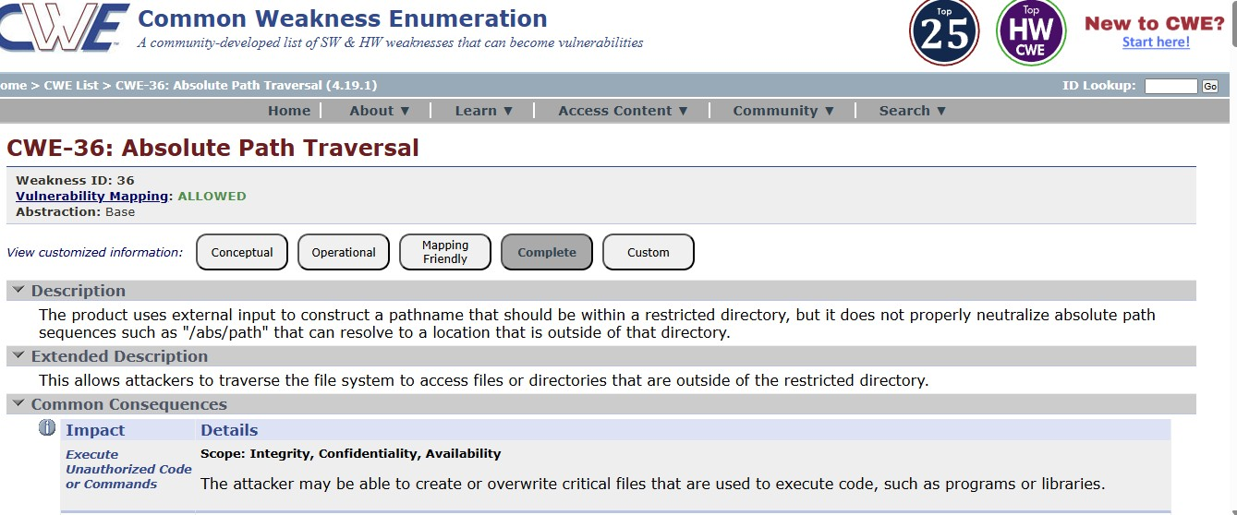

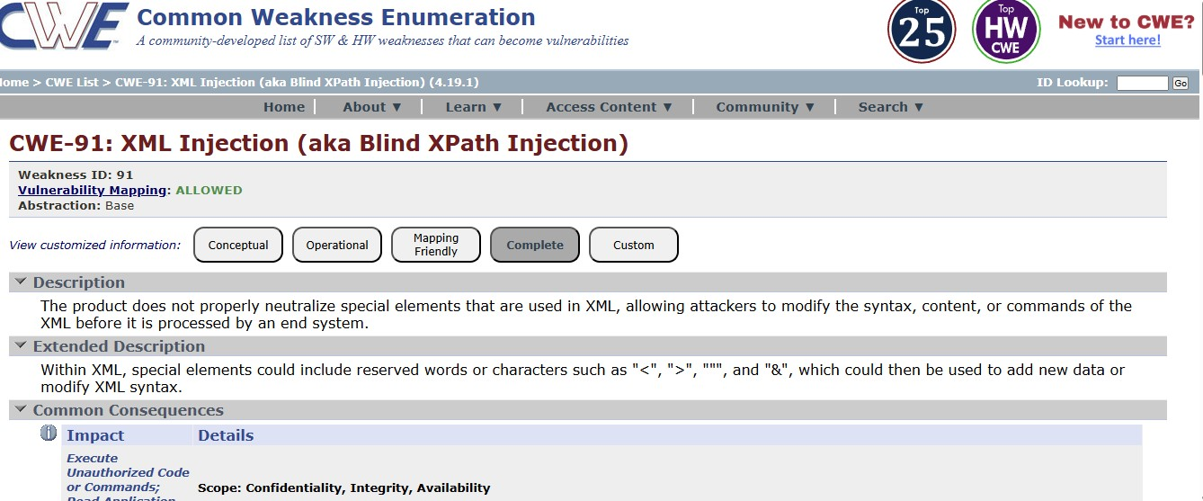
STAGE 2: TITLE: Nessus OVERVIEW:
Nessus is a popular vulnerability scanning tool developed by Tenable. It is widely used in cybersecurity to identify security weaknesses in computers, networks, servers, and applications. Nessus helps organizations detect vulnerabilities before attackers can exploit them, making it an important tool for maintaining system security.
Nessus works by scanning target systems using thousands of plugins that check for known vulnerabilities such as missing patches, weak passwords, open ports, and misconfigured services. During the scan, it analyzes the system and compares the results with its vulnerability database to identify potential security risks. The detected vulnerabilities are then categorized based on their severity level.
After completing the scan, Nessus generates detailed reports that include information about the vulnerability, its severity, possible impact, and recommended solutions to fix the issue. These reports help security professionals understand the risks and take corrective actions. Because of its accuracy, regular updates, and easy-to-use interface, Nessus is widely used for vulnerability assessment and security auditing in many organizations.

LIST OF VULNERABILITIES:
s.no | Vulnerability name | Severity | plugins
1 | General | info | 46180
2 | Service Detection | critical | 20007
3 | General | info | 11219
REPORT:
TARGET IP WEBSITE: https://ginandjuice.shop/
TARGET IP ADDRESS: 34.246.169.176
Vulnerability name: General
Severity: info
Plugins: 46180
DESCRIPITION:
This informational finding indicates general system information discovered during the vulnerability scan. It may include details such as system configuration, network services or host- related information identified by the scanner. This type of result does not represent a direct vulnerability but provides useful information about the target system that can assist in further security analysis.
SOLUTION:
Review the information revealed by the scan and ensure that only necessary services and system details are exposed. Limit unnecessary information disclosure by properly configuring services, disabling unused ports, and implementing appropriate security controls
BUSINESS IMPACT:
Although this issue is informational and does not directly impact security, exposed system information may help attackers understand the system environment. This information could potentially assist attackers in planning targeted attacks or identifying other vulnerabilities within the system.

REPORT:
TARGET IP WEBSITE: https://public-firing-range.appspot.com
TARGET IP ADDRESS: 44.228.249.3
Vulnerability Name: Service Detection
Severity: Critical
Plugin ID: 20007

DESCRIPTION:
Service Detection identifies the network services running on a target system by analyzing open ports and the associated service versions. This information reveals details about the applications, protocols and services active on the system. If these services are exposed or outdated, they may contain vulnerabilities that attackers can exploit.
SOLUTION:
Restrict access to unnecessary network services and close unused ports. Ensure all services are properly configured and updated with the latest security patches. Implement firewall rules and network segmentation to limit service exposure and reduce potential attack surfaces.
BUSINESS IMPACT:
If exposed services are discovered by attackers, they may analyze the service versions and attempt to exploit known vulnerabilities. This can lead to unauthorized system access, data breaches, service disruption, or complete compromise of the affected system. Proper service management and security controls are necessary to reduce these risks.

TARGET IP WEBSITE: https://www.flipkart.com
TARGET IP ADDRESS:.103.243.32.90
REPORT:
Vulnerability Name: Service Detection
Severity: Critical
Plugin ID: 20007
DESCRIPTION:
Service Detection identifies open ports and the services running on a target system. The scan reveals details about active network services and their versions. If these services are exposed to the network or contain outdated versions, attackers may use this information to identify potential vulnerabilities and target the system.
SOLUTION:
Limit exposure of unnecessary services by closing unused ports and disabling services that are not required Ensure all running services are updated with the latest security patches. Implement firewall rules, network segmentation, and access control mechanisms to restrict unauthorized access to these services.
BUSINESS IMPACT:
Exposed service information can help attackers identify vulnerable services and exploit known weaknesses. This may lead to unauthorized system access, data breaches, service disruption, or compromise of critical systems, affecting business operations and organizational security.

STAGE 3:
TITTLE: Design and apply context-aware access controls based on user identity, device posture,location,and application risk.
OVERVIEW:
Context aware access control is an advanced security approach that evaluates multiple contextual attributes before granting access to systems, applications, or data. Unlike traditional access control mechanisms that rely only on usernames and passwords, context-aware systems analyze factors such as user identity, device security status, geographic location, network environment, and the sensitivity of the application being accessed.
This model is commonly used in Zero Trust Architecture, where every access request is continuously verified. The goal is to ensure that access decisions are dynamic, risk-based, and adaptive to changing conditions. By implementing context-aware access controls, organizations can reduce unauthorized access, strengthen authentication mechanisms, and protect sensitive business resources from cyber threats.

IDENTITY :
Identity is the primary component in access control systems. It verifies that the user requesting access is legitimate. Identity verification typically involves authentication mechanisms such as usernames and passwords, multi-factor authentication (MFA), biometrics, smart cards, or digital certificates.
Modern identity management systems also integrate Identity and Access Management (IAM) solutions to enforce role-based or attribute-based access policies. These systems ensure that users are granted only the permissions necessary to perform their tasks. Continuous identity verification can also detect suspicious login patterns, such as unusual login times or abnormal user behavior.
Strong identity controls help organizations prevent unauthorized access, account takeover attacks, and credential misuse.

DEVICE POSTURE:
Device posture refers to the security condition and compliance status of the device used to access a system. Before allowing access, security systems check whether the device meets predefined security requirements. These checks may include:
- Operating system version and patch status
- Presence of antivirus or endpoint protection software
- Disk encryption status
- Firewall configuration
- Device compliance with organizational security policies
If a device fails these checks, the system may block access or allow only limited access to less sensitive resources. Device posture validation helps prevent compromised or untrusted devices from accessing critical organizational systems.

APPLICATION RISK:
Application risk refers to the sensitivity and security level associated with a particular application or service. Different applications require different levels of security depending on the type of data they process.
For example:
- Email systems may require moderate security controls.
- Financial systems or healthcare applications require strict authentication and monitoring.
- Administrative portals may require privileged access controls.
Risk assessment considers factors such as data sensitivity, regulatory compliance requirements, and potential impact of compromise. High-risk applications may require stronger authentication methods such as MFA, device verification, and stricter session monitoring.

CONTENT AWARE ACCESS :
Content-aware access control focuses on monitoring and protecting the actual data being accessed or transmitted. It analyzes the content of files, messages, or data transfers to detect sensitive information.
This approach is often implemented using Data Loss Prevention (DLP) technologies.
Content-aware systems can:
- Detect sensitive data such as financial information or personal records
- Prevent unauthorized data transfers or downloads
- Restrict sharing of confidential documents
- Monitor data access patterns to identify potential insider threats
By analyzing the content being accessed, organizations can prevent accidental or malicious data leakage

CONCLUSION :
STAGE 1:
In Stage 1, several application vulnerabilities were identified and analyzed based on CWE and OWASP Top 10 (2025) categories. The assessment detected security issues such as
Absolute Path Traversal, Sensitive Cookie Misconfiguration, Unmaintained Third-Party
Components, Unprotected Credential Transport, XML Injection, Protection Mechanism Failure, Weak Password Requirements, Embedded Malicious Code, Information Loss or Omission, and Missing Default Case in Conditional Expressions.
These vulnerabilities indicate weaknesses in access control, authentication, input validation, logging, and software component management. If not properly addressed, they may lead to unauthorized access, data leakage, system compromise, and service disruption. The findings provide a clear understanding of the system’s security gaps and help prioritize remediation to improve the overall security of the application.

STAGE 2 :
Stage 2 focused on performing a network vulnerability assessment using the Nessus vulnerability scanning tool to identify security weaknesses within the target system. The scan detected findings such as General Information Disclosure (Plugin 46180), Service Detection (Plugin 20007), and General Host Information (Plugin 11219). These results indicate that certain system details and network services are visible during the scanning process.
The Service Detection vulnerability, marked as critical, shows that active network services and open ports can be identified on the system. If these services are outdated or misconfigured, attackers may exploit them to gain unauthorized access or disrupt system operations. The informational findings also reveal system configuration details that could assist attackers during the reconnaissance phase.
Overall, the Nessus scan helped identify potential exposure points within the network environment. The findings provide valuable insights that can help security teams strengthen system configurations, reduce unnecessary service exposure, and improve the overall security posture of the system.

STAGE 3 :
This is focused on designing and applying context- aware access control mechanisms based on multiple security factors such as user identity, device posture, location, application risk, and content awareness . unlike traditional authentication methods that rely only on usernames and passwords, this approach evaluates different contextual attributes before granting access to systems or sensitive resources.
A by integrating identity verification, device security checks, and application risk analysis, organizations can make dynamic and risk- based access decisions . this model is commonly aligned with the principles of zero trust architecture , where every access request is verified continuously regardless of network location. implementing context- aware access control improves security by ensuring that only authorized users with secure devices and appropriate permissions can access critical applications and data.
Overall, the implementation of context- aware access control strengthens system security, reduces unauthorized access risks, and enhances protection of sensitive organizational information.

FUTURE SCOPE:
STAGE 1:
To improve the security of the system in the future, several measures can be implemented:
- Adopt secure coding practices to reduce application vulnerabilities.
- Perform regular vulnerability scanning and penetration testing.
- Implement strong authentication mechanisms such as multi-factor authentication (MFA).
- Improve logging, monitoring, and alerting systems for better incident detection.
- Regularly update and maintain third-party components.
- Apply data protection techniques such as encryption and secure configurations.
Implementing these improvements will strengthen the system’s security, reduce cyber risks, and ensure better protection of sensitive data and business operations.

STAGE 2:
In the future, the security of the system can be enhanced by conducting regular vulnerability scans, applying timely security patches and updates, and restricting unnecessary network services. Implementing firewall rules, network segmentation, and strong access control mechanisms can also reduce the risk of unauthorized access. Additionally, organizations should establish continuous monitoring and logging systems to detect suspicious activities early. By adopting these security practices, the organization can significantly improve its ability to prevent cyber attacks and protect critical systems and data.

STAGE 3:
To further improve the effectiveness of context- aware access control systems, several enhancements can be implemented in the future:
- Integrate advanced Identity and Access Management ( IAM) solutions for centralized access control.
- Implement stronger authentication methods such as multi- factor authentication ( MFA) and biometric verification.
- Deploy advanced device posture assessment tools to continuously monitor endpoint security.
- Use artificial intelligence and behavioral analytics to detect abnormal user activities and potential insider threats.
- Integrate Data Loss Prevention ( DLP) technologies to strengthen content- aware access monitoring.
- Continuously update access policies based on evolving security threats and organizational requirements.
These improvements will help organizations build a more adaptive, secure, and resilient access control framework capable of protecting systems and sensitive data from modern cyber threats

Topics Explored :OWASP top 10,scanning , Vulnerability ,awareness, identity Tools Explored: Zscaler,nessus,Owasp,hackthissite

